Project 3: Centralized Security Architecture (Inspection Patterns)

Instead of putting a separate firewall in every VPC, all important traffic goes through one central checkpoint. Think of an airport security line that everyone passes through.
- Security VPC: a VPC that holds the firewalls.
- Network Firewall or Gateway Load Balancer (GWLB): two ways to run the checks. Network Firewall is an AWS-managed firewall. GWLB spreads traffic across firewall appliances.
- Inbound and outbound: traffic coming in from the internet and traffic going out are both checked, with the same rules.
- Your job: define and govern these patterns so every team gets the same protection.

Network diagram
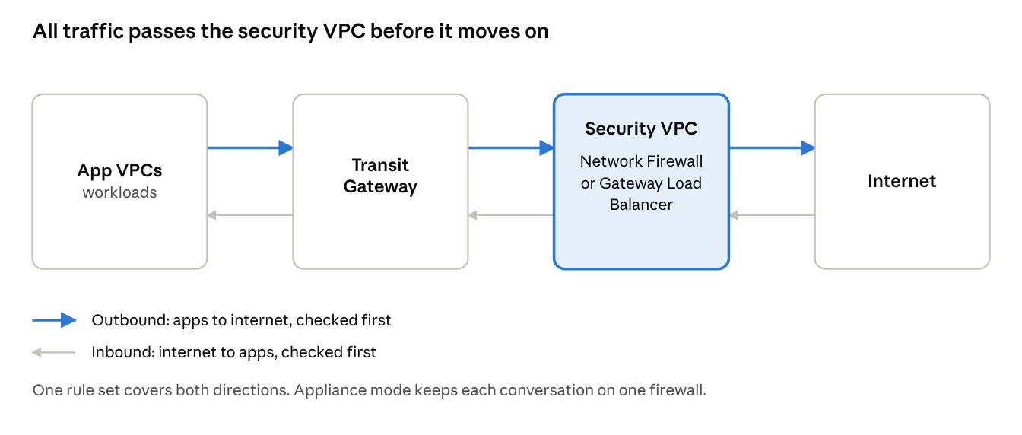
central inspection · inbound and outbound paths
App traffic crosses the Transit Gateway to the security VPC, is checked, and only then moves on. Internet traffic coming in takes the same road in reverse.

Inspection patterns
Pattern | How it works | Good for
Security VPC with AWS Network Firewall | Transit Gateway sends traffic to firewall endpoints in the security VPC. AWS runs the firewall. | Teams that want less to operate
Security VPC with Gateway Load Balancer | GWLB spreads traffic across firewall appliances and sends it on after the check. | Teams that already use a third-party firewall
Keeping rules consistent
- Inbound: internet traffic enters through one shared entry point, is inspected, then reaches the app.
- Outbound: app traffic goes to the security VPC, is checked, then leaves to the internet.
- Turn on appliance mode on the Transit Gateway attachment so both directions of one conversation use the same firewall.
- Keep one rule set, owned by the security architecture team, not one per VPC.

Production use case
Example scenario: a payments company must prove that every call from its apps to the internet is logged and limited to approved websites.
- All app VPCs send outbound traffic to the security VPC through the Transit Gateway.
- The firewall allows only an approved list of domains and logs every connection.
- Customers reach the apps through one shared entry point that is also inspected.
- During an audit, the team shows one rule set and one set of logs for the whole company.
Result: the same protection for every app, and a simple answer for auditors.

Interview questions and answers
Practice questions at the depth that senior cloud-network interviews at companies like AWS, Google and Meta expect. They are not official lists.
Q1. Why centralize inspection instead of a firewall in each VPC?
One rule set, one place to log, and less to operate. The trade-offs are a shared choke point, extra cost for traffic that passes through it, and a bigger blast radius if a rule is wrong. Many companies centralize internet-facing and cross-network traffic, and keep low-risk paths simple.
Q2. Network Firewall or Gateway Load Balancer with third-party appliances?
Network Firewall is managed by AWS, so there is less to patch and scale. GWLB suits teams that need a specific vendor's features or already run that vendor on-premises. Choose on required features, skills, and licence cost.
Q3. Users see random connection drops through the firewall. What could it be?
A common cause is asymmetric routing: the request goes through one firewall and the reply through another, so the firewall drops it. Fix it with appliance mode on the Transit Gateway attachment and symmetric route tables.
Q4. How do you avoid the security VPC becoming a single point of failure?
Run firewalls in several AZs, use health checks, and keep capacity headroom. Test AZ failure on purpose. For GWLB, make sure appliances scale out and that failed ones are removed from rotation.
Q5. How do you design outbound internet control?
Send all outbound traffic to the security VPC. Allow only approved domains, log every connection, and block everything else. Review the allow-list through a change process and keep logs for audit.
Q6. A firewall rule blocks a production app by mistake. What is your response?
Restore service first: roll back the rule through the pipeline, or apply the approved emergency path. Then find the cause from logs, add a test that would have caught it, and review how the change was approved.

